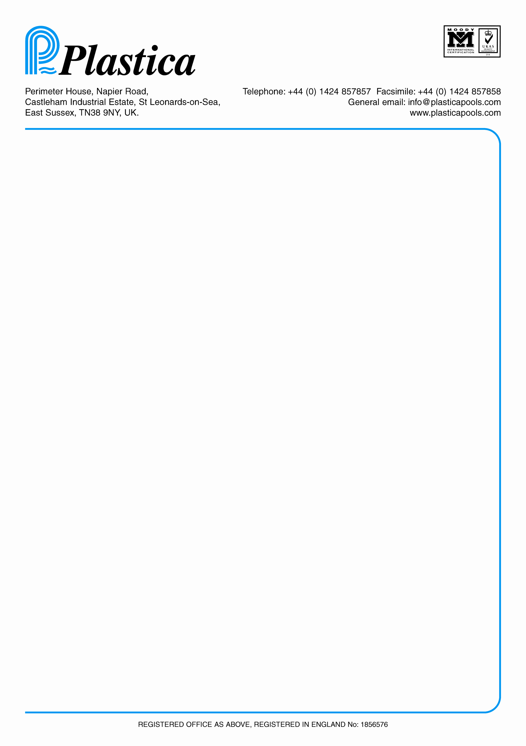

CONTROL OF MAJOR ACCIDENT HAZARDS

**IN THE EXTREME WORKSHOP**

To Dave Blower and Dan Howe.

Your department has within it equipment and goods which could potentially cause a major fire -:

**It is your responsibility to ensure that the following is carried out.**

1. **All gas tanks are turned off when not in use.**
2. **All heating is turned off at the end of the working day.**
3. **Battery charging is turned off at night.**
4. **The working area is kept tidy and clear of rubbish.**
5. **All rubbish bins are emptied regularly.**
6. **All flammable goods are stored carefully.**
7. **Fire extinguisher is accessible at all times.**

**Please inform your people of the danger of not carrying out these safety points.**

**CONTROL OF ALL VISITORS**

**\*\*It is essential that all visitors are signed in and out.**

**\*\*The staff in / out board must be used correctly.**

We must know who is on site at all times.

Smoking is only permitted in the external smoking shelter which is just outside the service and maintenance department and whilst you are inside your own personal car. Smoking is only permitted during your contracted breaks (tea(if applicable) and lunch)

**THIS IS A COMAH SITE AND POTENTIALLY VERY DANGEROUS.**

Dave Blower Dan Howe