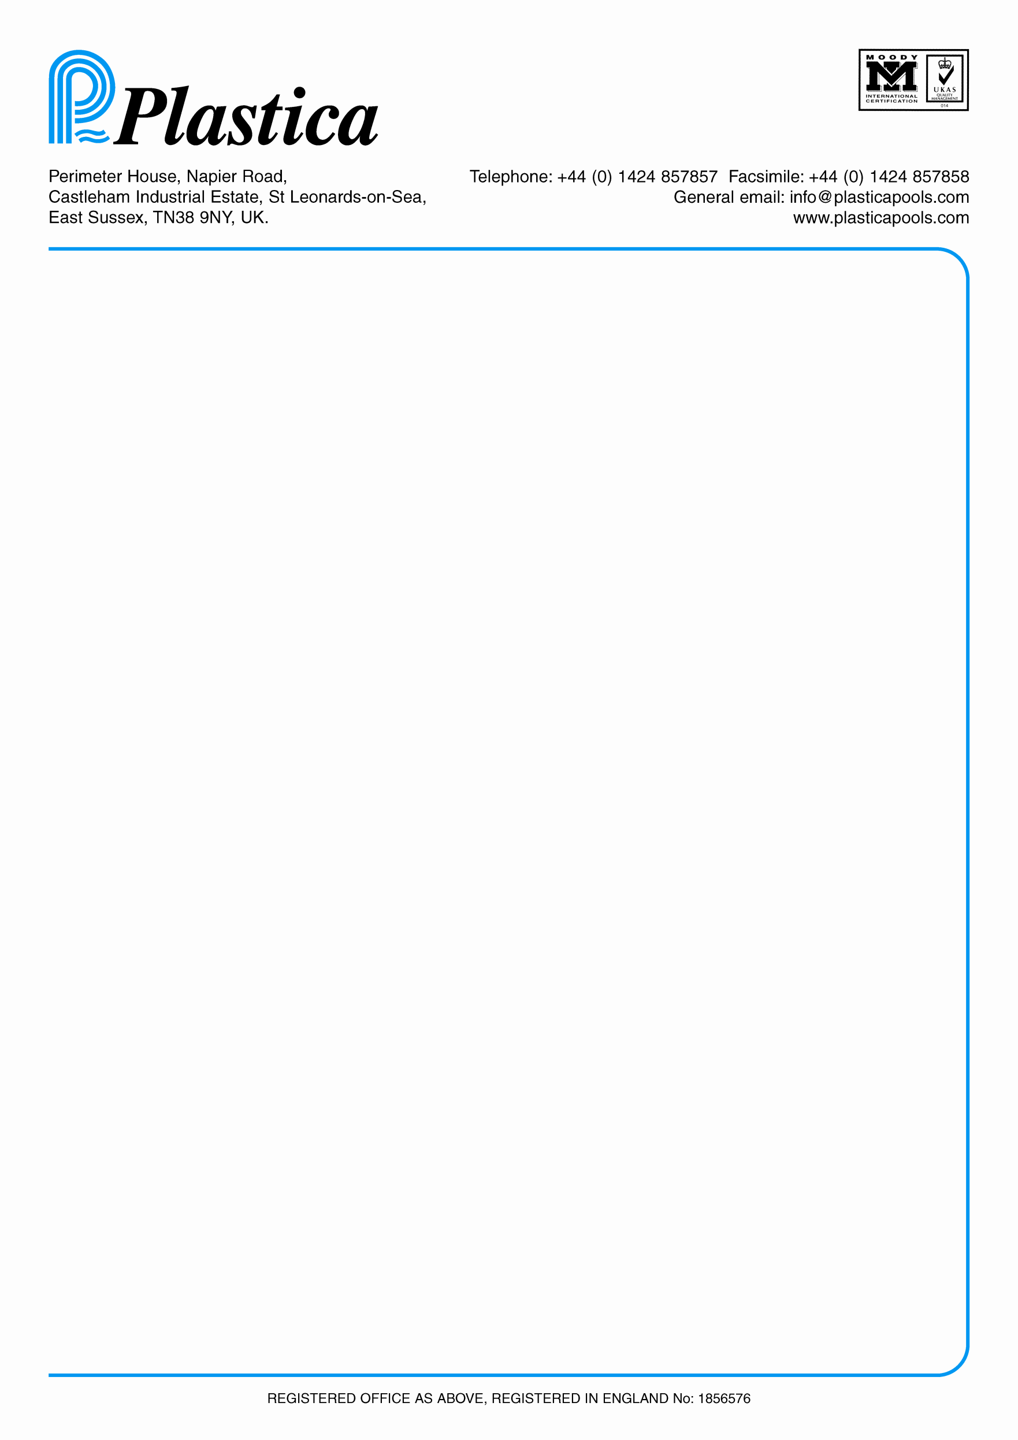

**C**ONTROL **O**F **M**AJOR **A**CCIDENT **H**AZARDS

**IN THE OFFICE BLOCK**

To Edward Campbell-Salmon, Ian Warne, S

teve Smith and Patrick Devaney

Your department has within it equipment and goods which could potentially cause a major fire -:

**It is your responsibility to ensure that the following is carried out.**

1. **All machinery is turned off at the end of the working day..**
2. **Electric heating and air conditioning is turned off at the end of the working day.**
3. **All fire exits are kept clear.**
4. **All fire alarms and extinguishers are accessible at all times.**
5. **All offices are kept tidy and rubbish bins are emptied regularly.**
6. **Please inform your people of the danger of not carrying out these safety points.**

**CONTROL OF ALL VISITORS**

**\*\*It is essential that all visitors are signed in and out.**

**\*\*The staff in / out board must be used correctly.**

We must know who is on site at all times.

Smoking is only permitted in the external smoking shelter which is just outside the service and maintenance department and whilst you are inside your own personal car. Smoking is only permitted during your contracted breaks (tea(if applicable) and lunch)

**THIS IS A COMAH SITE AND POTENTIALLY VERY DANGEROUS.**

Edward Campbell-Salmon Ian Warne

Steve Smith Patrick Devaney